meeting 1 & meeting 2

**Next steps**

6.13 - 6.17 Finish the project plan and review the final version of my project plan

6.19 - 6.26 run the raw code and attempt the different methods (code implementation)

**Questions or things that might block the progress**

1. is there any similar literature that has implemented active learning on multi-classification problems from which the code can be reproduced

2. suggestions for project plans, ideas from other literature, and improvements

3. when PyCharm goes to implement the script, there is a default situation, prompting that the specified file cannot be found; I wonder what the problem is. Is this something that can be run directly with .sh?

4. if implemented, how long would the timeline be and how long would it normally take to complete the first version of the code?

Meeting 3

**Update on what I have done so far**

1. Update my project plan according to generate the explanation process and add ExpBERT and Openai API literature review.

2. Apply the openai API private key (30 reply cost 4 pounds)| Because it costs a lot, I use repeat words instead. I will use it when all the bugs have been repaired

3. Code implementation: Split no_exp data into two parts and use random sampling to select the instance to give explanations. The explained data will be transferred to initialise the embedding process and classifier model.

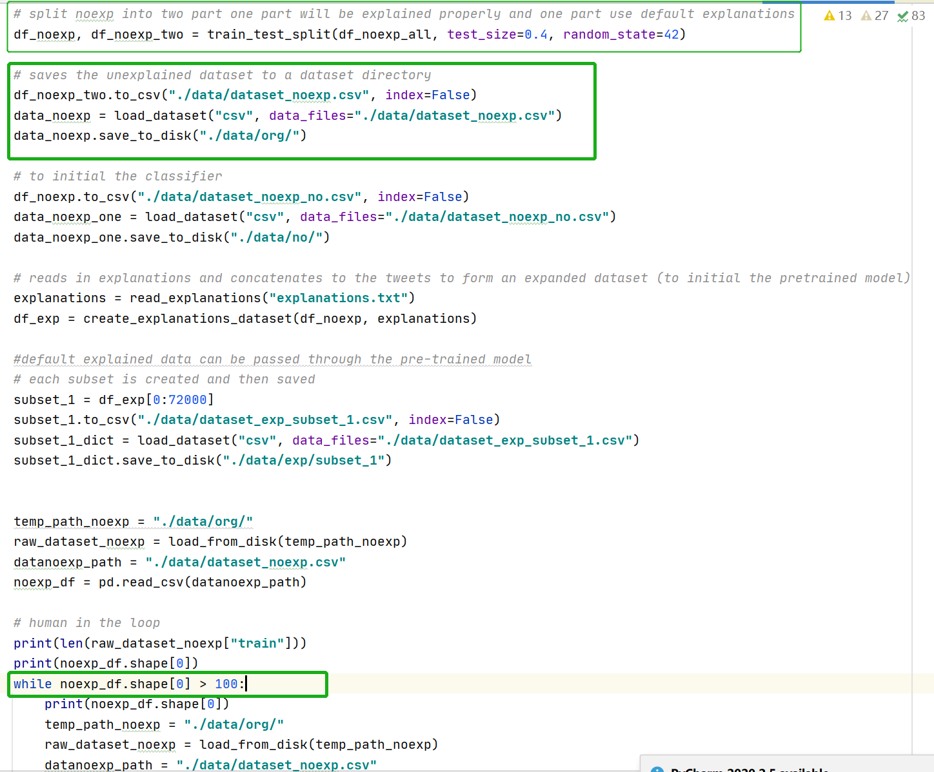

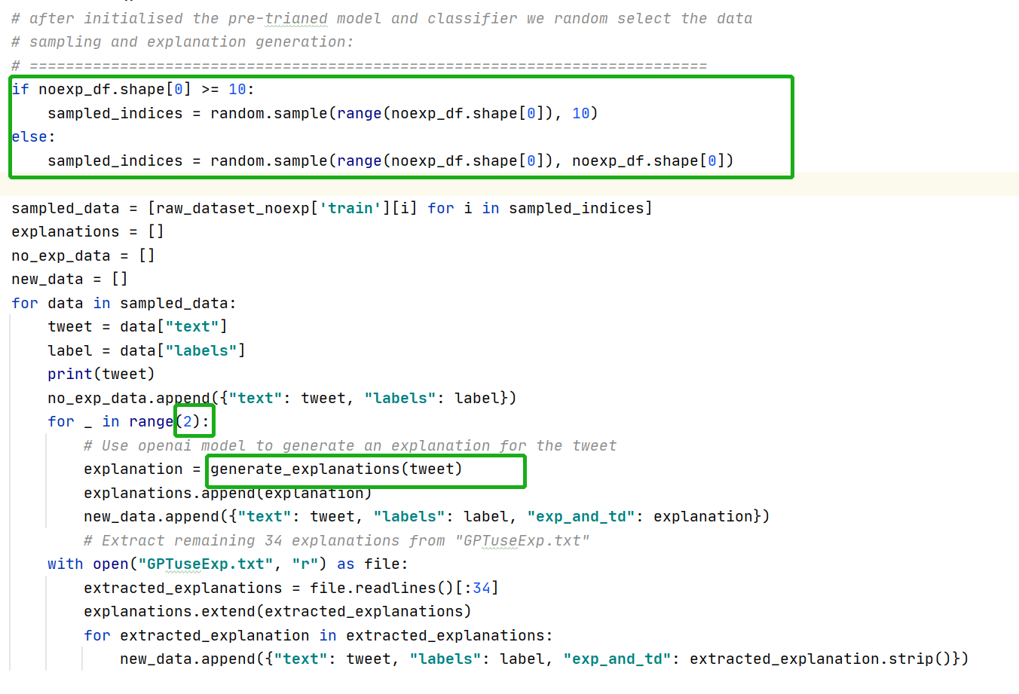

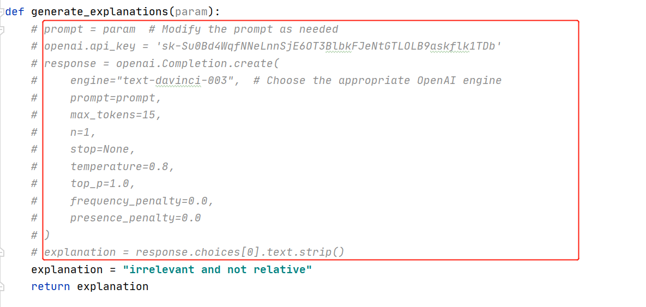

1. Add explained samples to the default explanation dataset. Delete them from original dataset and repeat the steps.

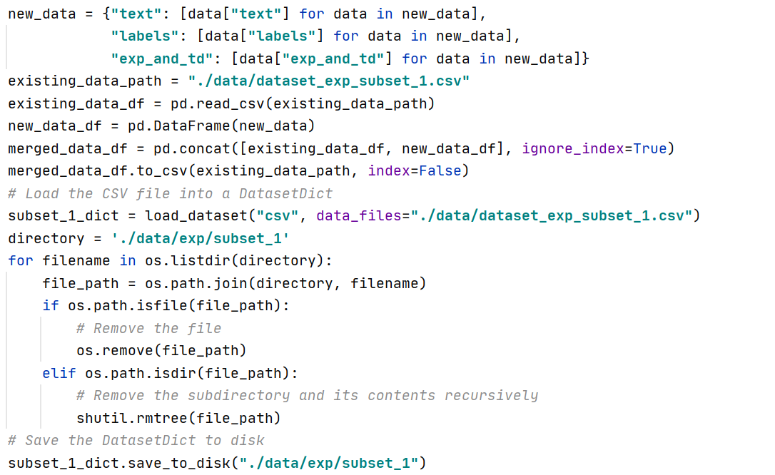

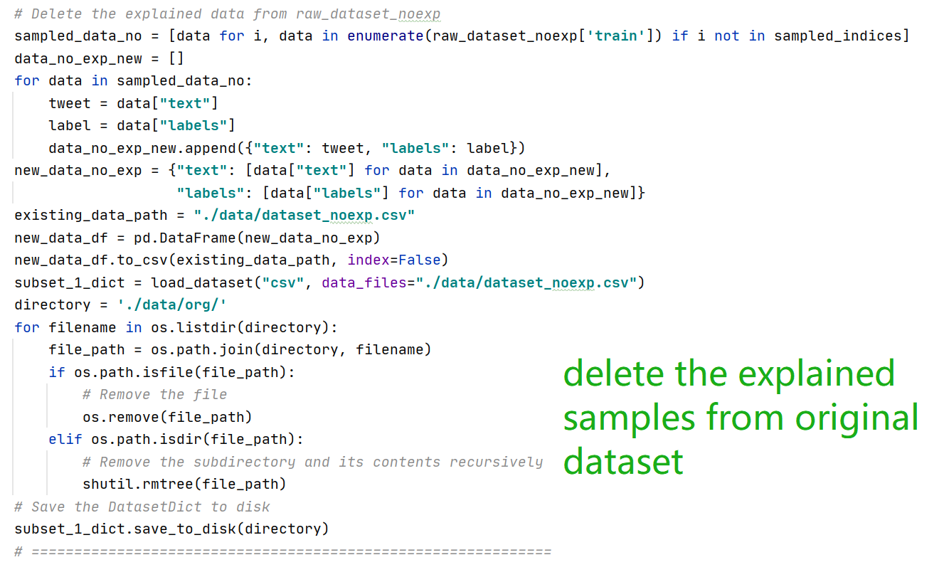

**Next steps**

1. Use uncertainty sampling to select samples instead the random sampling

2. Use a costless explanation generation method (low-cost openAI model)

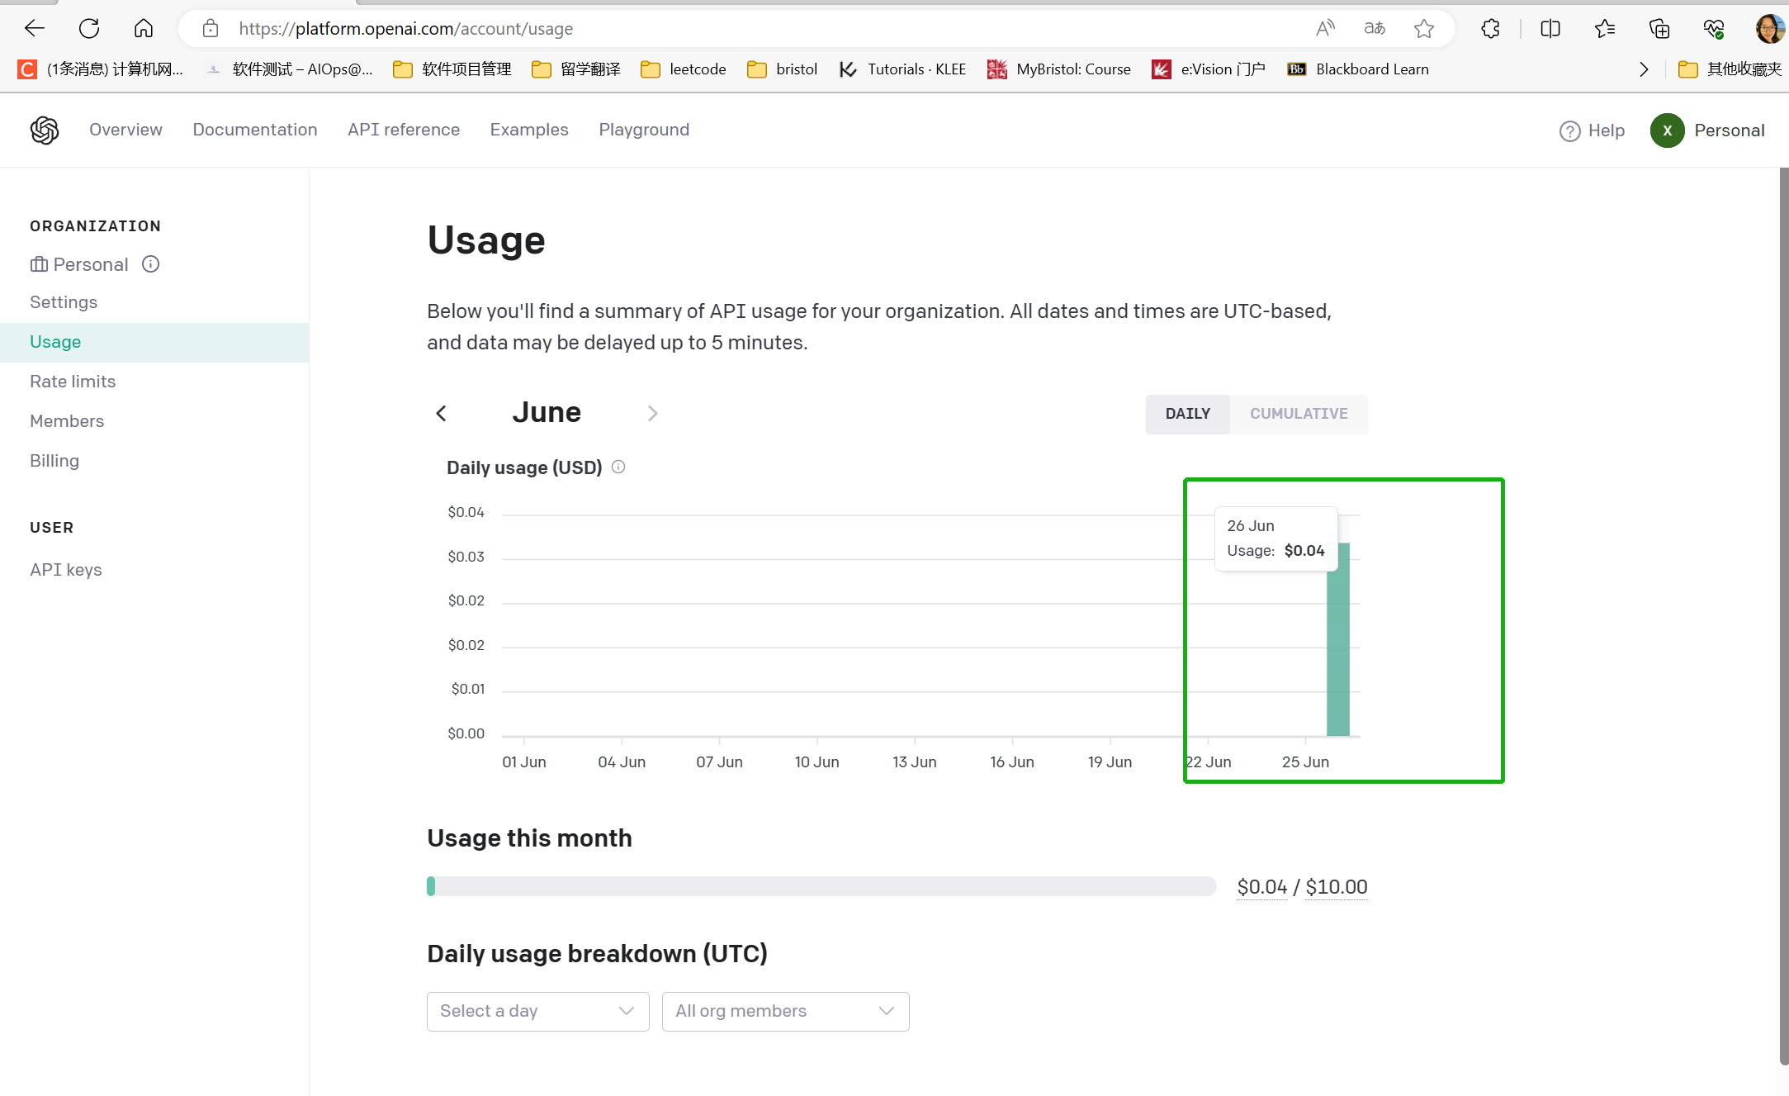

3.Find how to evaluate the performance(the final test results as one loops’ performance)

**Questions or things that might block the progress**

1. Can I submit the project plan

2. Is there any cost-friendly explanation generation methods? (openai is a little bit expensive)

3. Suggestion for the code implementation so far